Cross-quantilogram: EURUSD and EURGBP
Method 20 / daily log returns / expanding quantiles / Alpari D1 full available history

Study setup
Logical pair: EURUSD , EURGBP
Broker symbols: EURUSD_i , EURGBP_i
Snapshot: 2026-11-03_majors_alpari_D1
Timeframe: D1
Matched return window: 1999-01-06 to 2026-11-02 (UTC bar dates)
Matched return count n: 7183
Dropped unfinished last bar dated 2026-11-03 UTC after a tick-volume check against the prior complete day.
Quantiles: expanding window, min history 252 days
tau in [0.05, 0.2]; k=0..10; headline tau=0.05, k=1
Complete matched rows (Excel): EURUSD-EURGBP_CQ_D1.xlsx
Complete matched rows (HTML table): EURUSD-EURGBP_CQ_D1_data.html

Method carried forward
The cross-quantilogram rho_tau(k) measures linkage among centered quantile-hit indicators of matched daily log returns of close, ln(close_t / close_t-1). Quotes are not inverted. At each date t, the tau-quantile uses only returns through t (expanding window) after a minimum history of 252 days. Hits are h_t = 1(r_t < q_t) - tau. rho_tau(k) is the normalized cross-product of h_x,t with h_y,t+k. Levels tau in {0.05, 0.20} and lags k=0..10 are pre-specified; headline is tau=0.05, k=1 both directions. Same-sample Pearson r is a side check. This is not causation and not a trading signal.

Results (headline)
rho_EURUSD->EURGBP(tau=0.05,k=1): 0.050666
rho_EURGBP->EURUSD(tau=0.05,k=1): 0.038286
rho_EURUSD->EURGBP(tau=0.20,k=1): 0.029998
rho_EURGBP->EURUSD(tau=0.20,k=1): 0.045387
Pearson r: 0.439899

CQ table (tau=0.05)
k | rho_EURUSD_to_EURGBP | n_EURUSD_to_EURGBP | rho_EURGBP_to_EURUSD | n_EURGBP_to_EURUSD
0 | 0.32716337 | 6932 | 0.32716337 | 6932
1 | 0.05066587 | 6931 | 0.03828569 | 6931
2 | 0.03002223 | 6930 | 0.06303638 | 6930
3 | 0.04651947 | 6929 | 0.04651947 | 6929
4 | 0.03825593 | 6928 | 0.05476334 | 6928
5 | 0.05475359 | 6927 | 0.0423729 | 6927
6 | 0.06299771 | 6926 | 0.02998221 | 6926
7 | 0.03409918 | 6925 | 0.05473408 | 6925
8 | 0.04647029 | 6924 | 0.03408921 | 6924
9 | 0.02582512 | 6923 | 0.02582512 | 6923
10 | 0.05057772 | 6922 | 0.02168796 | 6922

Conclusion
Headline tau=0.05, k=1 for EURUSD and EURGBP: rho_EURUSD->EURGBP = 0.0507; rho_EURGBP->EURUSD = 0.0383. At tau=0.20, k=1: 0.0300 and 0.0454. Same-day tau=0.05 rho(k=0) = 0.3272. Pearson r = 0.4399. This is quantile-hit linkage, not a trading signal.

Charts
Daily closes

Daily log returns

Cross-quantilogram tau=0.05
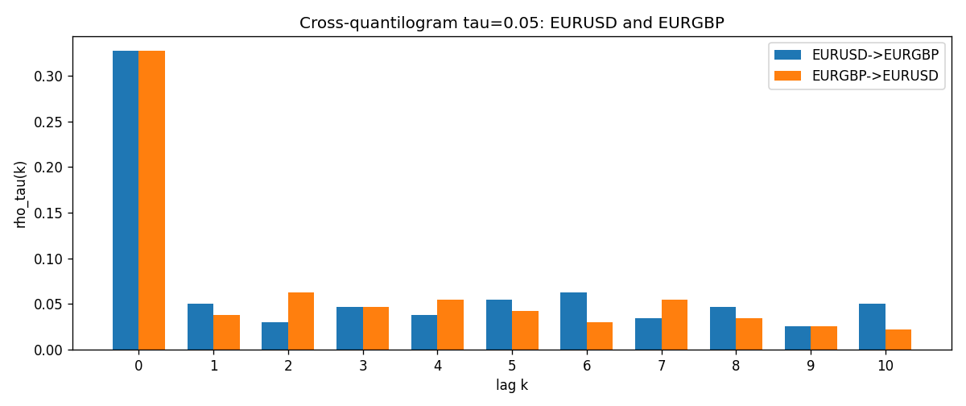

Data report
Matched rows and the CQ sheet are in the sibling Excel workbook named EURUSD-EURGBP_CQ_D1.xlsx. Embedding all rows as a Word table is impractical; this file holds column summaries and the first and last 15 matched rows.
Columns: time, EURUSD_open, EURGBP_open, EURUSD_high, EURGBP_high, EURUSD_low, EURGBP_low, EURUSD_close, EURGBP_close, EURUSD_tick_volume, EURGBP_tick_volume, EURUSD_spread, EURGBP_spread, EURUSD_real_volume, EURGBP_real_volume, EURUSD_log_return, EURGBP_log_return, EURUSD_h_t005, EURGBP_h_t005
Column summaries (matched calculation rows)
column | count | mean | std | min | 25% | 50% | 75% | max
EURUSD_open | 7183 | 1.1815763 | 0.15079461 | 0.8272 | 1.08621 | 1.16623 | 1.29409 | 1.5995
EURGBP_open | 7183 | 0.78698868 | 0.09663692 | 0.5734 | 0.6877 | 0.83389 | 0.86522 | 0.9769
EURUSD_high | 7183 | 1.1867072 | 0.15139096 | 0.8326 | 1.09029 | 1.17134 | 1.29941 | 1.6038
EURGBP_high | 7183 | 0.79006638 | 0.09701205 | 0.5789 | 0.6897 | 0.8369 | 0.8681 | 0.9799
EURUSD_low | 7183 | 1.1765677 | 0.15011491 | 0.8227 | 1.08209 | 1.16259 | 1.288515 | 1.5865
EURGBP_low | 7183 | 0.78428899 | 0.09645396 | 0.5682 | 0.6857 | 0.83166 | 0.86287 | 0.9661
EURUSD_close | 7183 | 1.1816163 | 0.15076829 | 0.8267 | 1.086135 | 1.16619 | 1.2941 | 1.5997
EURGBP_close | 7183 | 0.78703222 | 0.09663758 | 0.5735 | 0.6878 | 0.83395 | 0.86536 | 0.977
EURUSD_tick_volume | 7183 | 103246.15 | 173560.03 | 218 | 9420.5 | 52790 | 99596.5 | 1471626
EURGBP_tick_volume | 7183 | 87133.93 | 145499.42 | 154 | 6594.5 | 44358 | 81413 | 1424684
EURUSD_spread | 7183 | 19.326744 | 16.542159 | 0 | 8 | 12 | 20 | 50
EURGBP_spread | 7183 | 21.324655 | 19.119277 | 0 | 4 | 13 | 40 | 50
EURUSD_real_volume | 7183 | 4.0347326e+10 | 1.669497e+11 | 0 | 0 | 0 | 0 | 3.6149665e+12
EURGBP_real_volume | 7183 | 2.7872287e+10 | 1.3521454e+11 | 0 | 0 | 0 | 0 | 3.5726265e+12
EURUSD_log_return | 7183 | -5.81e-06 | 0.0057996 | -0.03123819 | -0.00324487 | 0 | 0.00325442 | 0.03433183
EURGBP_log_return | 7183 | 2.227e-05 | 0.00487305 | -0.03067367 | -0.00262314 | -9.879e-05 | 0.00256076 | 0.06075387
EURUSD_h_t005 | 6932 | -0.01624351 | 0.18061477 | -0.05 | -0.05 | -0.05 | -0.05 | 0.95
EURGBP_h_t005 | 6932 | -0.01148298 | 0.19245468 | -0.05 | -0.05 | -0.05 | -0.05 | 0.95
First 15 matched rows (selected columns)
time | EURUSD_log_return | EURGBP_log_return | EURUSD_h_t005 | EURGBP_h_t005
1999-01-06 | -0.011547966 | -0.013303338 | nan | nan
1999-01-07 | 0.0076280636 | 0.011051402 | nan | nan
1999-01-08 | -0.010902799 | -0.004943862 | nan | nan
1999-01-11 | -0.007103287 | -0.0012752393 | nan | nan
1999-01-12 | 0.0045103728 | 0.0033970309 | nan | nan
1999-01-13 | 0.010845346 | 0.00042381861 | nan | nan
1999-01-14 | 0 | -0.0019793588 | nan | nan
1999-01-15 | -0.010153245 | -0.0076715819 | nan | nan
1999-01-18 | 0.0036256946 | 0.00071280921 | nan | nan
1999-01-19 | -0.00017235436 | -0.0014261269 | nan | nan
1999-01-20 | -0.0031939256 | 0.0019960086 | nan | nan
1999-01-21 | 0.0030215416 | -0.00071240297 | nan | nan
1999-01-22 | -0.0012075213 | -0.0017118406 | nan | nan
1999-01-25 | -0.0030251979 | -0.0054402425 | nan | nan
1999-01-26 | 0.00086527651 | -0.00057438255 | nan | nan
Last 15 matched rows (selected columns)
time | EURUSD_log_return | EURGBP_log_return | EURUSD_h_t005 | EURGBP_h_t005
2026-10-13 | 0.0037402957 | 0.00020130374 | -0.05 | -0.05
2026-10-14 | -0.0037582255 | 0.0011241873 | -0.05 | -0.05
2026-10-15 | 0.0056053107 | -0.00087557391 | -0.05 | -0.05
2026-10-16 | 0.0017724895 | -0.0020380844 | -0.05 | -0.05
2026-10-19 | -0.0025394633 | -0.00056950988 | -0.05 | -0.05
2026-10-20 | 0.0023881672 | -0.0035906254 | -0.05 | -0.05
2026-10-21 | -0.00032046717 | -0.00140647 | -0.05 | -0.05
2026-10-22 | -0.0015949606 | -0.0018743924 | -0.05 | -0.05
2026-10-23 | -0.001338521 | 0.00082421033 | -0.05 | -0.05
2026-10-26 | -0.0022706559 | 0.00013133309 | -0.05 | -0.05
2026-10-27 | -0.004152342 | -0.0019957343 | -0.05 | -0.05
2026-10-28 | 0.0022262927 | 0.00066967224 | -0.05 | -0.05
2026-10-29 | 0.0022571351 | -0.0011722209 | -0.05 | -0.05
2026-10-30 | -0.0011458446 | -0.0024205543 | -0.05 | -0.05
2026-11-02 | 0.002120569 | 0.00089940465 | -0.05 | -0.05

